**Global Sales Data Analytics**

|  |  |
| --- | --- |
| **Date** | **14-11-2022** |
| **Team ID** | **PNT2022TMID45267** |
| **Project Name** | **Global Sales Data Analytics** |

**Project Development Delivery of Sprint-3**

**Task 1: Merge 12 months of sales data into a single CSV file**

**Task 2: Create new ‘Month’ column from ‘Order Date’ column**

**Task 3: Add a Sales column**

**Task 4: Add a City column**

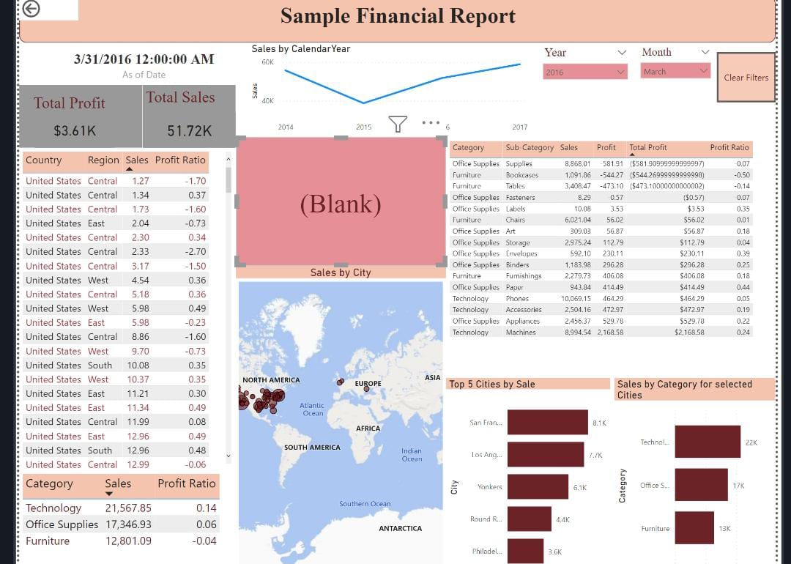

**Analysis of the sales data with Particular focus given to how promotions And advertising translate into sales, in terms of both units sold and sales Dollars.**

